Inventory of Septic Tanks
as a Source of Pollution in
Belvedere

Final Report submitted to the
Department of Natural Resources
of the Commonwealth of Puerto Rico

by

José Norat, Ph.D.

Department of Environmental Health
Graduate School of Public Health
Medical Sciences Campus
University of Puerto Rico

and

Hernando Mattei, Ph.D.

Department of Social Sciences
Graduate School of Public Health
Medical Sciences Campus
University of Puerto Rico

October, 2006

Inventory of Septic Tanks as a Source of Pollution in Belvedere

- Introduction and Rationale

- Septic tank pollution

Coral reefs and coastal waters in Western Puerto Rico are subject to stresses due to water pollution from non-point sources. Septic tanks are one of the most important non-point sources of water-borne pathogens and several inorganic pollutants. Contamination by septic tank systems is a real problem that does not count with the attention that it really should have. Studies have demonstrated that some outbreaks of hepatitis, gastroenteritis and the Norwalk viruses have been cause by contamination of ground water by septic tanks. Badly designed and operated septic tank systems do not work effectively to remove pathogens, and can cause the dispersion of contamination factors such as total coliforms and fecal coliforms. Suspended solids carried by runoff from overflowed septic tanks during storm events and organic and inorganic chemicals from seeping sewage may also contribute to coral reef degradation. A comparison between the ecological health status of coral reefs near these onshore pollution sources and offshore coral reefs provides information on the ecological impact of septic tanks in the region.
In addition to loading of subsurface water, onsite disposal systems, such as septic tank and injection wells, are known to be source of microbial contamination of surface water. The maximum age for the best functioning of a septic tank is 20 years. Many of the septic tank systems in Puerto Rico are older than 20 years and an outflow of these systems can result in serious problems. Studies have demonstrated that bacteria and viruses can be transported through the subsurface and contaminate groundwater many hundreds of meters horizontally and survive for weeks. Another important point is that contaminants produced by septic tanks can be deposited in the bottom of rivers and lakes for several weeks before they die. For this reason some studies have found lower densities of bacteria in the water column but higher in sediments samples. Densities have been found of total and fecal coliforms between 6-45 MPN/100ml versus 150-2088 MPN/100ml in the water and sediments respectively (MPN = Most Probable Number). These bacteria can live for weeks in the bottom and can be affect recreational activities.

- Study site

The Belvedere Natural Reserve was established in February 2003 by the Puerto Rico Planning Board. It is located in the municipality of Cabo Rojo on the West Coast of Puerto Rico, (approximately centered in 18°N 05' N and 67°W 11') and covers a coastal area of 256.36 acres of wetlands. The ecologically sensitive wetland of the Reserve is bordered by the Puerto Real settlement of Barrio Miradero. Figure 1 shows a United States Geological Survey aerial photo taken in November 1993 where we can observe the wetland area right next to a densely populated urban settlement that is encroaching on the ecologically sensitive land and water resources of the Reserve. According to the 2000 Census, Puerto Real had a population of 6,166 persons and 2,254 housing units (see Figure 2). To make the current situation more critical, old and substandard septic tanks have created a serious problem of water quality in the area, seriously damaging habitats within the Reserve and the coral reefs on the coastal zones surrounding the Reserve.
In this project the Department of Environmental Health (DEH), Graduate School of Public Health of the University of Puerto Rico Medical Sciences Campus conducted an Inventory of Septic Tanks as a Source of Pollution in the Belvedere Reserve, sampled and analyzed coastal waters near coral reefs, and evaluated the health of coral reef communities both inside and near the Reserve. The project was carried out in two phases of six months each.

Figure 1

Belvedere Natural Reserve and Puerto Real Settlement, November 1993

Source: United States Geological Survey (USGS)
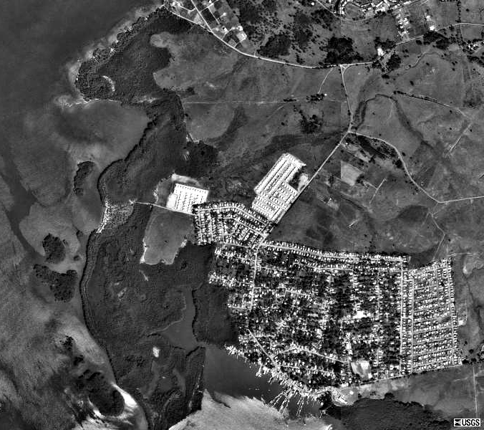

Figure 2

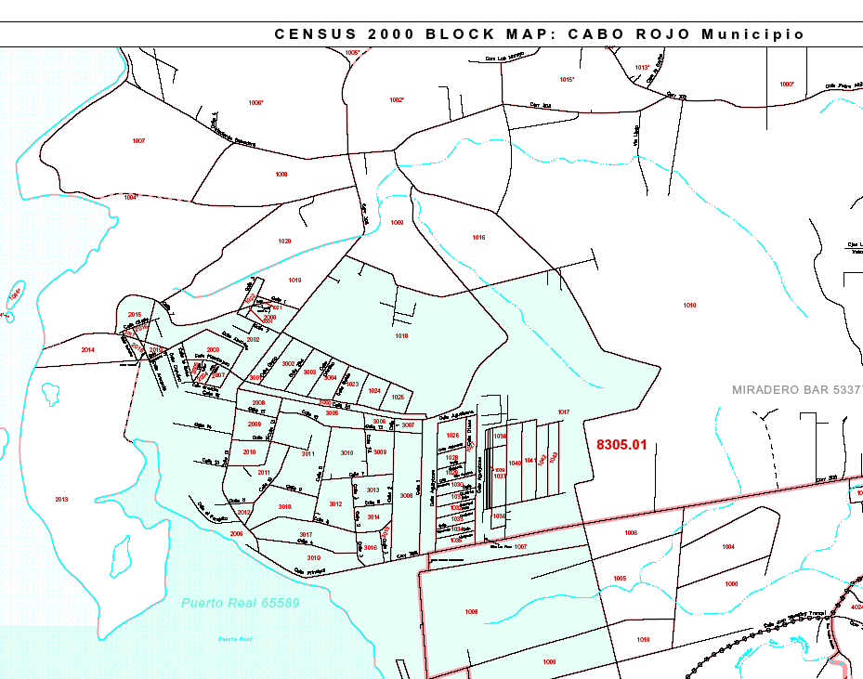
Census Tracts, 2000, Belvedere Natural Reserve and Puerto Real Settlement

II Research Objectives

The objectives of this study were:

- To identify and do an inventory of housing units in the watershed of the Belvedere Reserve using remote sensing and Geographic Information System techniques.
- To classify housing units with septic tanks, sewage and sanitary sewage (i.e. with waste water treatment).
- To conduct household interviews and onsite inspections of septic tanks facilities of a representative sample of housing units of those communities lacking sewage facilities. The interviews and onsite inspection will be carried out to determine the conditions of the septic tank, and the household interviews will measure knowledge of the environmental impact of septic tanks and attitudes toward this problem.
- To determine the environmental health implications of this situation using digital georeferenced data on the phreatic level, geohydrology, water quality and location of known drinking water wells.
- To develop an Environmental Education Program through seminars on the design and operation of septic tanks addressed to members of the communities, government agencies and other stakeholders.

III Methodology/Approach

The study was carried out in two phases. During Phase 1 an inventory of septic tanks and households was completed. During Phase 2 the water column near coral reefs inside and near the reserve was sampled and analyzed to determine the quality of the coastal water in the coral reefs area.
In Phase, in order to carry out an inventory of septic tanks, Geographic Information Systems techniques were used to combine 1990 and 2000 Census data with data from the Puerto Rico Aqueducts and Sewers Authority (PRASA). A household physical survey of the Puerto Real community was also carried out. The household interviews to measure knowledge of the environmental impact of septic tanks and attitudes toward this problem were substituted with interviews with local environmental activists from the Fishermen’s Association. This was done due to the fact that mainly households lying below the street level near shore were operating problematic septic tanks. Fishermen were aware of this problem since the construction of sewer lines along Puerto real’s main shore street around 1990.
The planned Environmental Education Program through seminars on the design and operation of septic tanks addressed to members of the communities, government agencies and other stakeholders was substituted by other activities. These activities were providing scientific information and education to the Puerto Real Fishermen’s Association which was already involved in community action to clean the Puerto Real Bay. Information and advice on the septic tank problem, general microbial and physicochemical water quality in the study site, and general status of coral reefs was provided during the period leading up to its participation in the central government’s legislative public hearings regarding cleanup of Puerto Real Bay in March 2006. Afterwards, actions were taken by PRASA to clean sewer lines along Puerto Real’s main shore street and improve sewage pumps, which were provoking coastal sewage pollution events from overflow through bypass valves when malfunctioning.
Once the first phase was completed, in Phase 2 identified precisely the area of the Belvedere Reserve using recently obtained copies of legal documentation and GIS mapping techniques (see Figure 3 and Report Appendices). The water quality impact of onshore nonpoint pollution sources was precisely measured using microbiological, physicochemical and ecological coral reef parameters in the study area (see Figure 4).

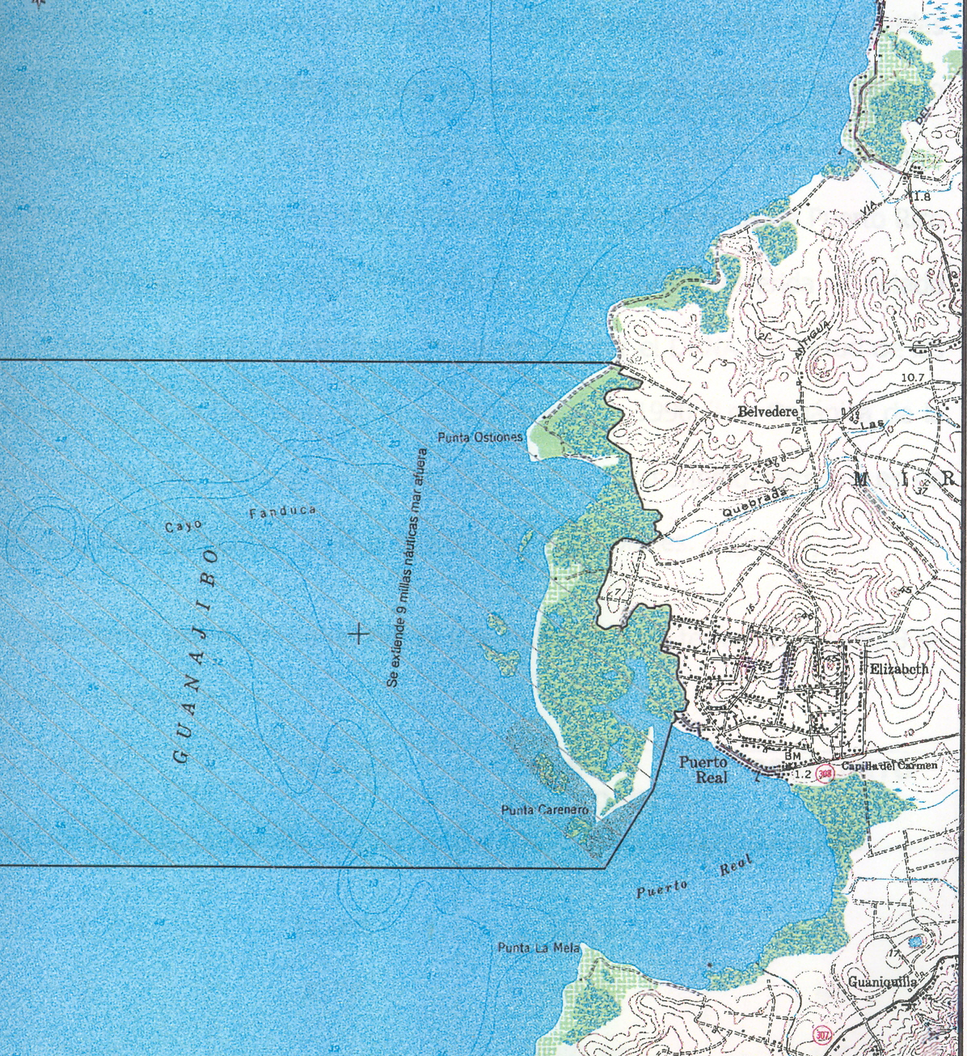

Figure 3. Belvedere Natural Reserve Limits.
USGS Puerto Real Topographic Map based on 1966 Data
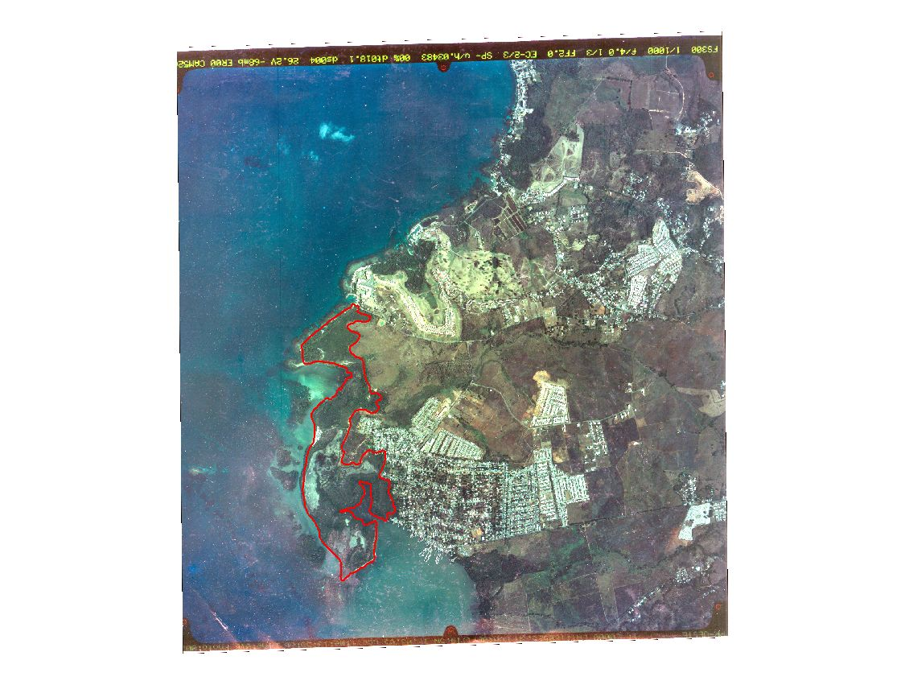
Figure 4. Study Area
2005 Aerial Photo of Belvedere Wetland and Puerto Real Settlement
Puerto Real Settlement

Puerto Real Bay

\

Belvedere
Wetland

IV Summary of Results
- Land based human activity results
In the area surrounding the Belvedere Wetland a total of 2,060 residential units and commercial establishments were identified with 435 septic tanks. It is of concern that most of these septic tanks, 301 (69 percent), are located in close proximity to the Wetland and in the area next to the Puerto Real Bay (see Figure 3). A serious problem of septic tank discharges that reach the Wetland and the Bay area was found.
- Remote sensing results
Remote sensing analysis of the study area confirms that suspended sediment identified in Puerto Real nearshore waters apparently comes from land sources by runoff. Human activities such as construction and land cover modification in Puerto Real could be related with major sediment discharge to nearshore areas. There is also evidence that discharges from the Guanajibo River are having a major impact in the area of the Reserve. A qualitative evaluation of Guanajibo River suspended sediment plume was done using remote sensing techniques. Ortophotos with 4 and 2 meters spatial resolution collected by NOAA (National Oceanic Atmospheric Administration) and USDA (United States Department of Agriculture) were evaluated to identify the Guanajibo River plume and suspended sediment in nearshore areas for the 1999 to 2004 period.
Landsat Enhancement Thematic Mapper (ETM) images with 30 meters of spatial resolution was used to identify the river plume and suspended sediment for 2001 and 2003. Spectral bands 3 (red) and 2 (green) were used to discriminate suspended sediments in nearshore waters. Unsupervised classification procedure was used to conduct suspended sediment categories. General results showed that: 1) the Guanajibo River plume was identified in all images for 1999, 2001, 2003 and 2004 period; 2)the river plume varies in morphology and direction for each period; 3) major river plume direction is to the west and south. 4) major southward movement of river plume was identified for 2004 arriving close to Belvedere coastline; 5) a second major suspended sediment plume was identified in Puerto Real Bay at Cabo Rojo for all periods; 6) a major sediment plume distribution was identified for 2004.
Figure 5.

Number of Septic Tanks by Street Location in Area Next to the
Wetland and Puerto Real Bay, 2006
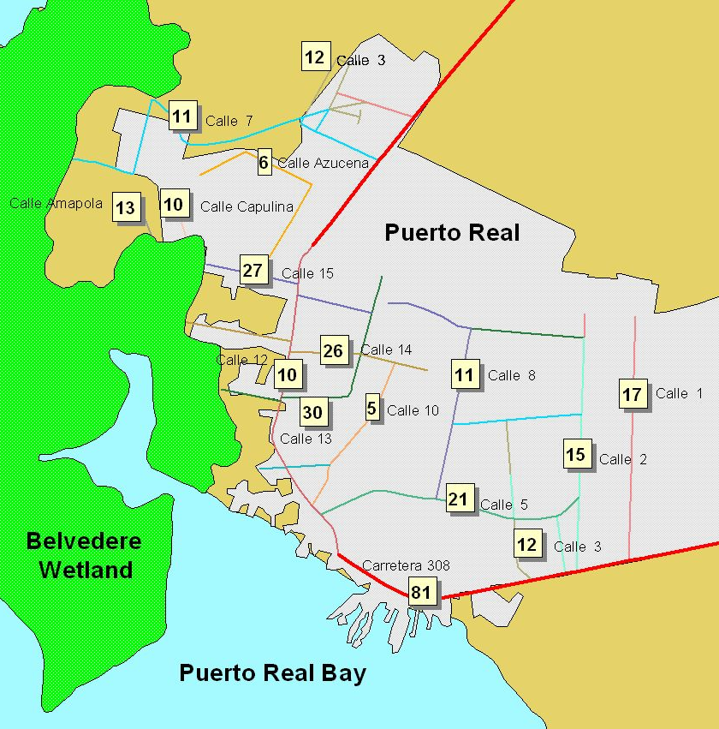

Número de pozos sépticos en cada calle

- Physicochemical analysis results
This study showed that water quality along the western coast of Puerto Rico is significantly influenced by land-derived activities that produce frequent non-point source pollution pulses. This has resulted in a nearly permanent state of high inshore water turbidity. Ten out of the thirteen study sites (77%) showed at any given moment violations to the existing water turbidity standard of 10 NTU for SB classified marine waters, as set by the PR Environmental Quality Board (EQB). Also, 50% of the time there were sampling sites showed turbidity violations. Oceanographic dynamics may often carry out turbid polluted waters offshore impacting significant coral reef and seagrass habitats that function as essential fish habitats for fish and macroinvertebrate species of high commercial value. Gradient patterns were not completely clear due to oceanographic variable dynamics during the course of the study, but evidence of overall habitat quality degradation suggest that there is a definite long-term trend of environmental degradation associated to human-derived water pollution.
Data shows evidence that turbid waters may significantly influence inshore waters, and often affect habitats located up to 10 km offshore, such as El Ron. Turbid and contaminated runoff from the Guanajibo River plume, as well as from non-point sources from Puerto Real Bay, Joyuda Bay, and possibly from Playa Buyé and Boquerón Bay, are negatively impacting inshore waters at a platform-wide scale.
- Microbiological analysis results
This region receives the direct and consistent impact of fecal contamination from local non-point sources that include: illegal crude discharges from residences and local businesses, infiltration of septic tanks, discharges without treatment that enter small streams that end in Río Guanajibo, possible waste dumping from boats and house-boats, and discharges of cattle and other animal farms. The influence of Guanajibo River represents one of the main sources of sediments and sewage pollution that cause increasing turbidity levels in the region. This situation affects the measurements of microbial indicators.
High fecal indicator counts revealed that the sites sampled received periodical influence of various non-point pollution sources. In several sampling sites fecal indicators detected were above the recognized standards by the Environmental Quality Board of Puerto Rico (EQB). For beaches these are 200 cfu/100mL, for fecal coliforms and 35 cfu/100mL for enterococci (EQB, 2006). These waters are mainly coastal and estuarine water used for primary and secondary contact.
The sampling stations were clustered into two groups according to the distance from the shoreline. Sites that were clustered into the “inshore” category (<0.5 km off the coast) showed violations to the EQB fecal indicator standards when all the sampling periods were included in that particular cluster. These sites are closer to point and non-point sources of fecal pollution.
The variability of the results suggests that presence of indicator bacteria varies notably during short periods of times. Clearly, the sites that went over the standards previously stated and are not suitable for recreational purposes.
The sites were clustered as Marine Protected Areas (MPA) and Non-Marine Protected Areas (Non-MPA). Sites that are included in MPA are Ron (Tourmaline Area), CR (Cayo Ratones and adjacent water resources), AF, PC and PRP (all part of Finca Belvedere Natural Reserve Marine Extension). The rest of the sites are Non-MPA. Based on the results obtained for FC and ENT for all sampling stations, the sites that were part of Non-MPA violated standards for the microbial fecal indicators tested. This could be a result of management practices for those sites. If this is the case, management practices need to be implemented, since some of these sites are used for commercial fishing and harbor coral reef and seagrass habitats.
Fecal coliform concentrations were overall higher in inshore sampling stations when compared to offshore sites. However, they showed fluctuations that seemed to be associated to factors such as: 1) tidal flow; 2) turbidity; 3) wind direction and speed; 4) heavy rainfall; and 5) Guanajibo river stream flow. These fluctuations are suggested by the presence of higher concentrations of fecal coliforms in samples collected during strong winds, ebbing tides followed by heavy rainfall runoff and after being impacted by the Guanajibo river plums. A similar pattern is evident in enterococci counts for these sites.
It is expected that some environmental parameters, such as water salinity can influence the presence of indicator bacteria. In this study the variations in salinity occurred in sites where estuarine or freshwater conditions persisted (GREB and GRM). However, fecal pollution could be detected for these two sites for all the months sampled. These results could indicate that this area is constantly polluted with non-point fecal contamination sources.
It is evident that Guanajibo River and other major bodies of water from the region have influences in water quality of the western shelf area of Puerto Rico. The peak values of Guanajibo River stream flow was registered in October 2005, but it was not possible to sample in this date due to weather conditions. However, during moderate but significant stream flow peaks (July 2005, August 2005, September 2005, and November 2005), microbial counts in Ron, PO, AF, PC, PLOB, PLIB, PRFV, and PRP were variable, being September 2005 the month with the highest values for fecal coliforms.

Sites close to sources fecal contamination like GREB and GRM registered the highest values for fecal coliforms and enterococci. This probably occurred because the river could be influenced by tributary streams where temperature, light, and/or nutrient conditions favor enhanced bacterial survival. Also non-point sources of contamination discharge into this river and pollutants are eventually carried out to the estuary.
Non-point source fecal pollution was detected along vast areas of the southwestern Puerto Rico platform. This is a threat to public health, since HF183 MST marker revealed fecal pollution coming from a human source. In this context, it is important to determine non-point sources of fecal pollution in order to prevent diseases, especially within MPAs used for fishing and recreational purposes. Moreover, human fecal pollution was found within MPA systems that support significant coral reef, seagrass and mangrove communities. These areas function as nursery, shelter, feeding and/or spawning grounds for a wide variety of fish and macroinvertebrate species of commercial significance. Chronic sewage pollution and eutrophication, in addition to other anthropogenic causes of stress (i.e., turbidity, sedimentation, overfishing), could have significantly contributed to the overall environmental degradation and ecological decline of these communities.
- Coral reef evaluation results
This study has shown evidence that coral reefs along a significant portion of the southwestern Puerto Rico shelf are being severely impacted by non-point source sewage pollution, mostly from human origin. The combination of historic natural factors (i.e., hurricanes) with long-term non-point source pollution, and other potential anthropogenic reef degrading factors, such as sedimentation and overfishing, have contributed to a dramatic phase shift in coral reef community structure. Phase shifts have favored dominance by macroalgae and non reef-building taxa. Such changes are generally irreversible at least in a human generation time scale (Knowlton, 1992; Hughes, 1994; Bellwood et al., 2004). Most often this is due to a phenomenon known as hysteresis, which is a phenomenon where a recovering community follows a different trajectory from that observed during the decline (Hughes et al., 2005). For instance, a declining reef previously dominated by massive corals might have shifted towards other community dominated by macroalgae or other non-reef building taxa. In the long-term, it may show some signs of recovery towards another alternate state such as dominance by octocorals. This is the case of Arrecife Fanduco, and most probably Punta Ostiones and Punta Arenas.
Declining coral reefs by sewage pollution along the western Puerto Rico shelf have resulted in significant declines of entire coral assemblages. This has resulted in a dramatic loss of functional redundancy (sensu Bellwood et al., 2003). The most dramatic example is the extirpation of Elkhorn coral from most inshore coral reefs. Acropora palmata constitutes a functional mono-specific group responsible of constructing an entire reef zone. Losing the palmata zone might have most probably resulted in a major biodiversity decline at the entire reef ecosystem level due to the net loss of nursery, shelter and feeding grounds of a myriad of fish and invertebrate species.
Another significant finding is that local MPAs had no significant impact on the status of coral reef benthic communities. Current management activities by the PR Department of Natural and Environmental Resources (DNER) at Tourmaline Natural Reserve, Cayo Ratones and Adjacent Waters Natural Reserve, and at Finca Belvedere Natural Reserve marine extension are largely limited. There are no specific management actions implemented either by DNER or the PR Environmental Quality Board (EQB) to address the imminent negative impacts of non-point source sewage pollution in coral reef ecosystems.
This study showed that coralline communities along the entire southwestern Puerto Rico coast are being constantly impacted by sewage pollution. Even offshore remote reefs are being often impacted by pollution pulses from the Guanajibo River plume, and during heavy sediment resuspension associated to variable oceanographic dynamics. According to ISRS, this could have paramount long-term negative impacts in reef communities by: (a) reducing coral larval production; (b) reducing coral recruitment; (c) increasing incidence of coral disease; (d) reducing coral skeletal density; (e) increasing coral mortality; (f) reducing coral species diversity; (g) producing a community phase shift; (h) enhancing bioerosion; (i) enhancing macroalgal growth and biomass; and (j) and by probably enhancing coral predators abundance.
It is probable that most inshore coral reefs along the southwestern Puerto Rico shelf have degraded beyond recovery within a human time scale. Further, water quality degradation is of such magnitude that recovery may never occur. Stronger efforts are needed from the government of Puerto Rico to prevent further degradation of remote reefs through the region. There is an immediate need to implement a sound management strategy to reduce and/or prevent non-point source sewage pollution impacts in coral reef habitats before we witness a reef ecological and socio-economic collapse within the next few years.

